Athaang P2P API structure

- Login:
URL: {baseulr}/api/login

Method: POST
Parameters(JSON):
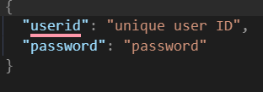
Response (success):
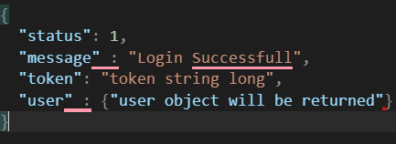
Response (unsuccessful) :
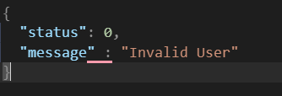

- Next screen (document waiting for approval):

URL: {base url}/api/approval-waiting

Method: GET

Headers: bearer access token : (login token)

Parameters :

Response :
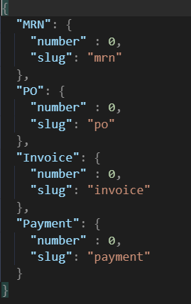

- List API for each list screen

URL: {base url}/api/order/list

Method: POST

Headers: bearer access token : (login token)

Parameters(JSON) :
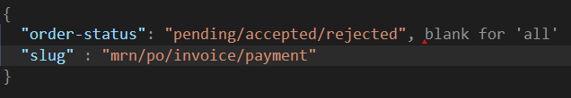

Response with pagination (when there is data):
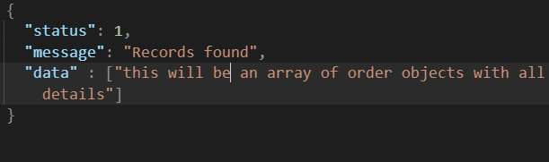

Response (when no data found):
